


Modbury Primary School Newsletter
Friday 9th January 2026

www.modburyprimaryschool.co.uk
https://www.facebook.com/p/South-Hams-Federation-61556768462697

https://www.instagram.com/southhamsfederation2025/

Dear Parents and Carers,
Happy New Year! It has been wonderful to welcome all the children back this week and hear all about what they have got up to.
It was lovely to end the week with a panto in the hall which the children thoroughly enjoyed! Lots of fun was had by all and some teachers even got to join in with a bit of dancing! Thank you to those who have paid a contribution to support this event. Without your support we would not be able to provide these opportunities for our pupils. If you have not yet had a chance to pay, the system will stay open until 19th January however, we are aware that there are a few technical issues at the moment so please bear with us.

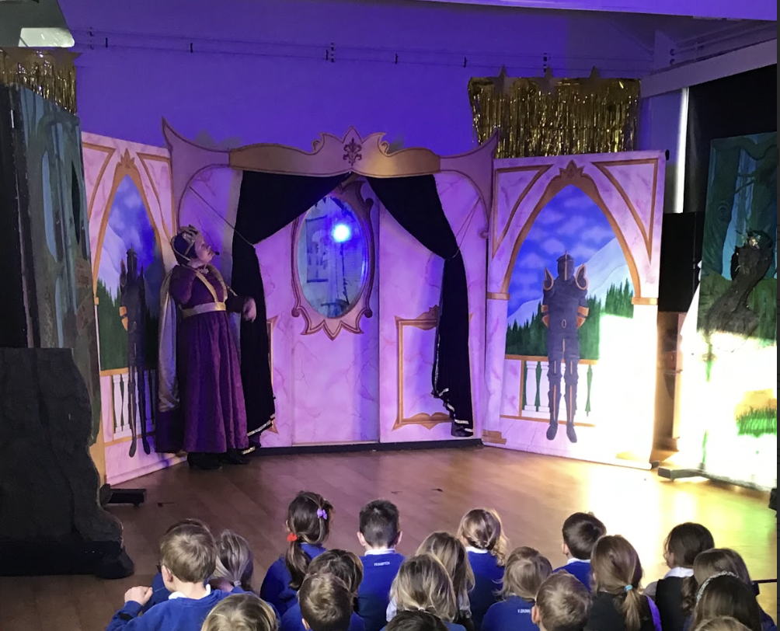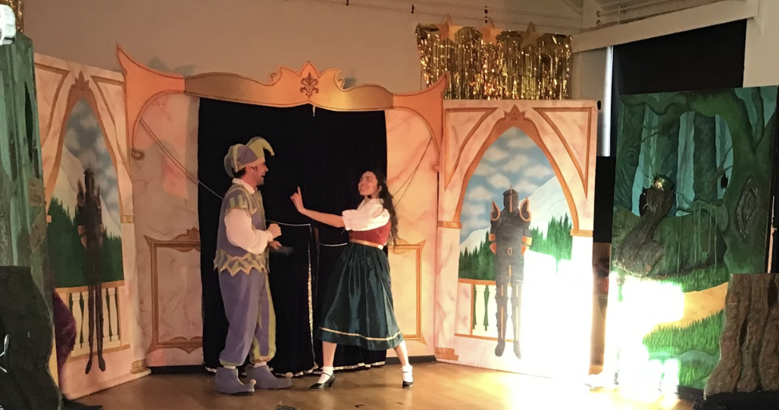

Activity Clubs

This term’s activity clubs went “live” under the Clubs section on MCAS this evening. They will be starting next week and will finish the last week before February Half Term.

The clubs on offer are:

After School Clubs – 3.30pm – 4.30pm

Y1 & 2 Mindful Colouring Club – Mondays
Y6 SATs Club – Wednesdays

Lunchtime Clubs

Y5 Chess Club – Mondays
Y1 & 2 Story Club – Wednesdays
KS2 TTRS Club – Thursdays
Y1 & 2 Lego Club – Thursdays
KS2 Cross Country Club – Thursdays (will continue after half term)
KS2 Nature/Gardening Club – Fridays

If you are unsuccessful in securing a place in a club for your child, you will be able to join a waiting list and will be contacted if/when a space becomes available.

Online Safety
This edition offers clear, supportive guidance to help parents and educators feel more confident in navigating the online world with children and young people. It looks at how everyday conversations, simple boundaries, and a bit of digital awareness can make a real difference to young people’s online experiences.
This guide also explores how parents and educators can create an environment where children feel comfortable asking for help when something online unsettles them. By highlighting the importance of safe and healthy internet usage, these tips provide a grounded starting point for anyone supporting young people’s digital lives.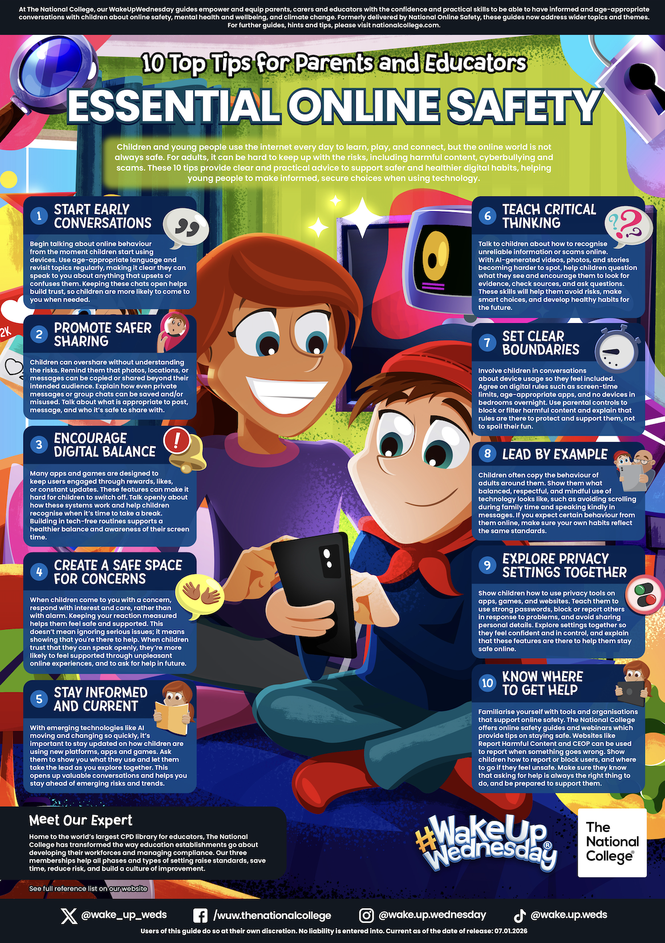
Achieve4All – Spring Term – until February Half Term

If your child would like to join/continue this Multi-Sports club on a Wednesday after school – 3.30pm-4.30pm, please follow the new link below to book.

Modbury | Wednesday | KS1+2 Multi Sports Club | https://activities.bookpebble.co.uk/activity/achieve4all-multi-sports-club-ks12-modbury-wednesday-ivybridge-fe504e4d-f52f-4a64-8f05-aec7424ffbe7

If you have any queries or questions you can contact them on: info@achieve4all.co.uk
Plymouth Argyle’s Y2 – Y6 Football After School Club - CANCELLED
Unfortunately, due to low numbers since September and the coach/transport costs not being met, Argyle have advised that they are not able to continue this club unto the New Year.
We are hoping to revisit this and have a new club set up for the summer term.
Diary Dates - New dates in bold
16th January - Extra choir and experienced Ocarina and Ukulele practice for those taking part in the Saltash music festival
29th January Sports Games at ICC - Year 4,5,6 - Information to follow as we receive it
29th January Saltash Music Festival - Letters have gone out to those taking part
4th- 6th February Year 5 Residential
4th February Reception children vision screening


Stars of the Week

Reception – Chloe
Year 1 – Teddy
Year 2 – Steven
Year 3 – Bo
Year 4 – Becky
Year 5 – Aiden
Year 6 - Jack

A special mention to Logan in Year 3 for amazing focus this week and to Connie MT in Year 4 for writing an amazing story!


AR This week’s highest word count…
Year 2 – Louis, Emily, Bernie
Year 3 – Delilah, Grace, Isabelle
Year 4 – Evie, Connie MT, Max
Year 5 – Rose, Freya, Dom
Year 6 - Ella, Jack, Sam

AR This year’s highest word count…
Year 2 – Emily, Louis, Barney
Year 3 – Alice, Delilah, Elliot
Year 4 – Evie, Jasper, Connie MT
Year 5 – Otis, Jack, Felix
Year 6 - Maisy, Seb, Jack

Overall highest Otis with an amazing 743,928 words!

TTRS
Number of correct answers in 2026!
Year 2 Rosie, Toby F, Barney
Year 3 River, Eddie, Ellen
Year 4 Stanley, Woody, Lawrence
Year 5 Freya, Dom, Martha
Year 6 Ella

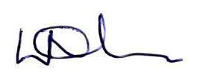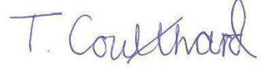
Louise Nicholls Mrs T Coulthard
Head of School Executive Head Teacher

PTFA News

The Fabulous Friday Cake Stand is back for the Spring term! Each Friday we have a table in the lower playground to sell wonderful baked creations and contributions for just 50p per item. The money raised goes towards loads of cool stuff the PTFA support. Come along to our next meeting on Monday 19 January from 8pm at The White Hart pub, to find out more about what we do and how you can join in.

Here are the dates for each year group *Thank you everyone for your support!:

16 January | Yr 1
23 January | Reception
30 January | Yr 6
6 February | Yr 5
13 February | Yr 4

20 February | None as Half Term

27 February | Yr 3
6 March | Yr 2
13 March | Yr 1
20 March | Reception
27 March | Yr 6

Community News








